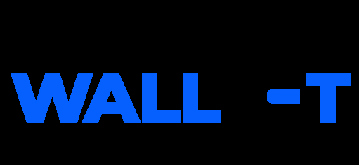 | 
Data Flow Diagram
Date | 15 March 2026
Team ID | SWTID-2026-8588
Project Name | SmartLender
Maximum Marks | 2 Marks

Data Flow Diagram
The diagram below shows how data moves through SmartLender — between external entities, processes, and data stores. Use the symbol legend as a guide to reading the diagram.
DFD Symbol Legend
Symbol | Name | Description
Oval / Rounded shape | External Entity | A person, organization, or system outside the project that sends or receives data (e.g., Loan Applicant, Loan Officer).
Rectangle with numbered header | Process | An activity that transforms incoming data into outgoing data (e.g., Authentication, Application Intake & ML Prediction).
Rectangle (solid fill, no number) | Data Store | A place where data is held for later use (e.g., User Store, Application/Prediction Store, Document Store).
Labeled arrow | Data Flow | The movement of data between entities, processes, and data stores, labeled with what data is being passed.

SmartLender — DFD Level-1
The diagram illustrates how a Loan Applicant's registration, income and credit details flow through Authentication, Application Intake & ML Prediction, and Admin/Review processes, and how a Loan Officer or Admin reviews and manages applications and predictions.
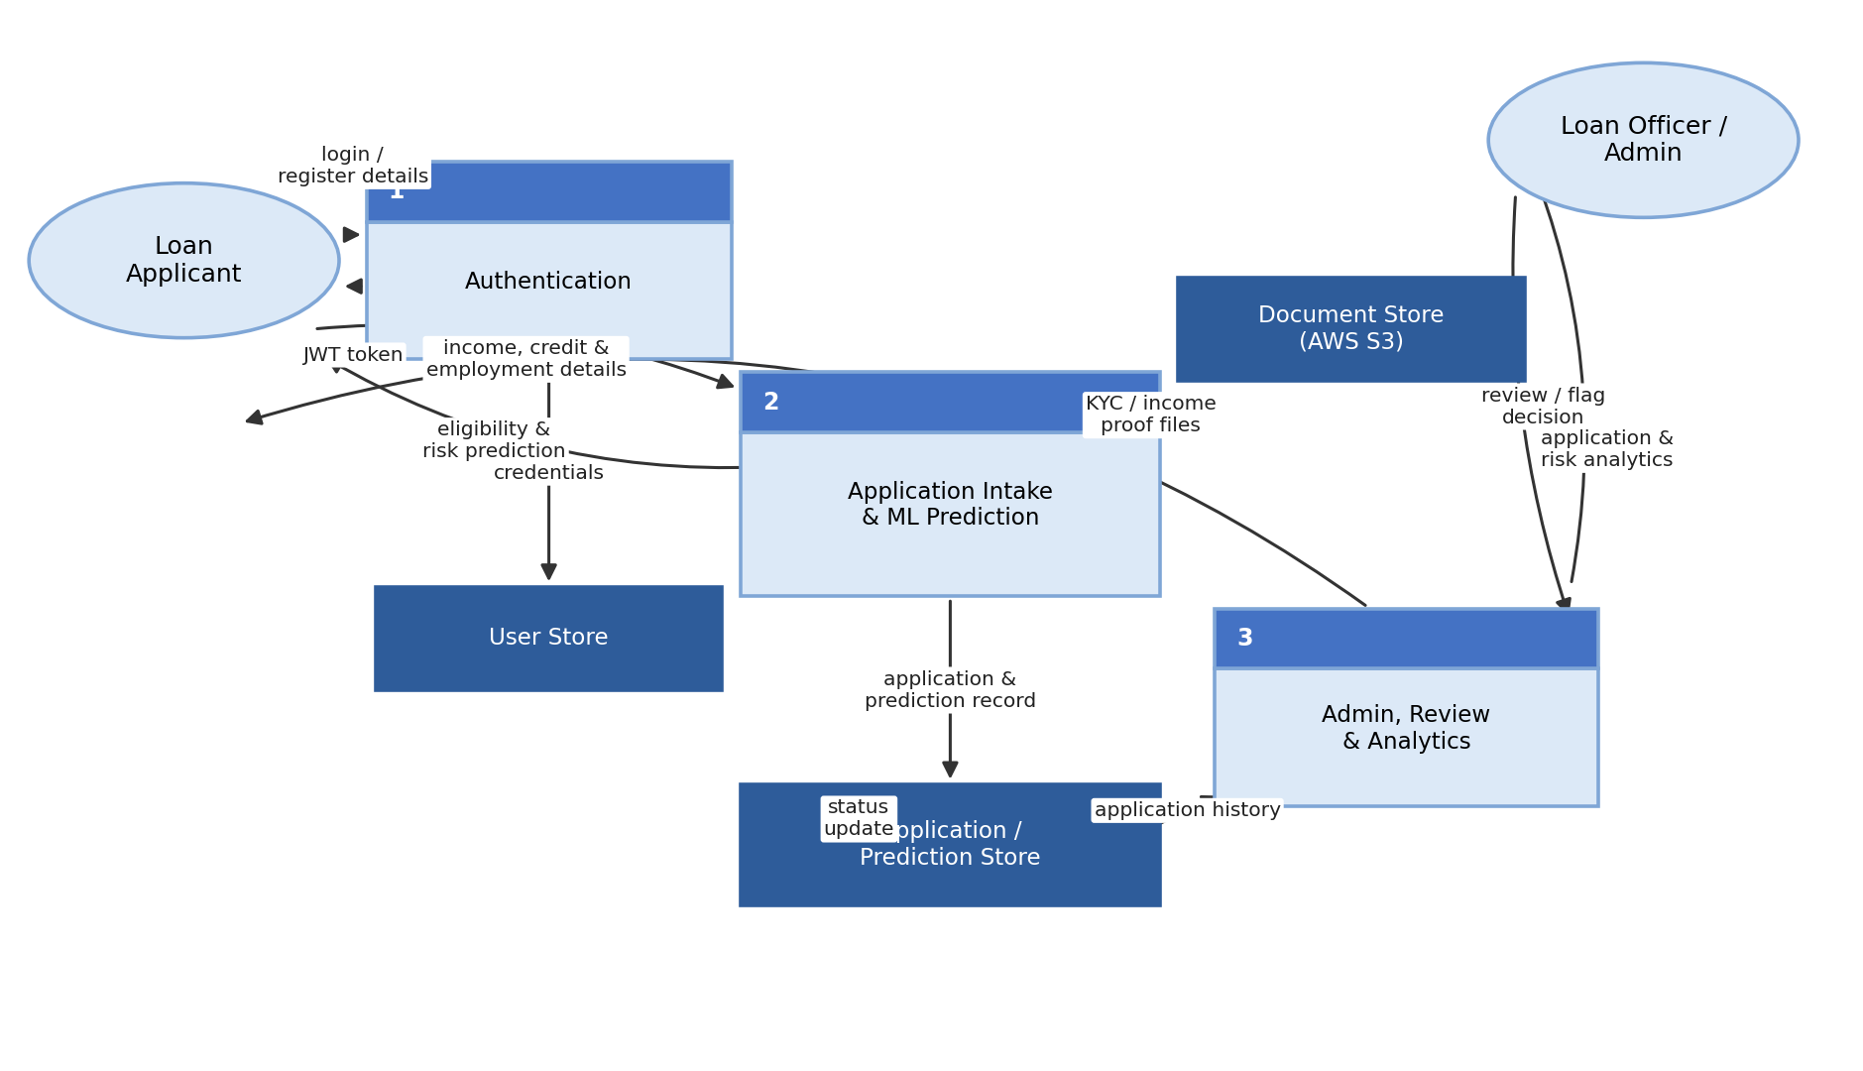
Figure: SmartLender DFD Level-1 — Authentication, Application Intake & ML Prediction, and Admin/Review modules with their associated data stores.

